ID3 Read Me

Introduction: This program is an ID3 Reader. It takes an mp3 file, and attempts to read various information about the mp3 file, such as: artist, album, genre, etc. The different versions have data in different formats which made it a little frustrating to implement and not every version is a set standard, as well.

Inputs: The user inputs an mp3 file that they would like to analyze. If the file is not there, the program will output an error, saying the file name is invalid and prompt for another file.

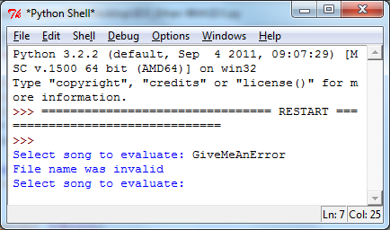

*An example of if an incorrect file name was given.*

Program:

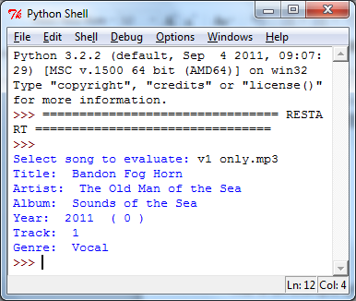

*This is an example of the data output from the “v1 only.mp3” file for the ID3v1 part of the program.*

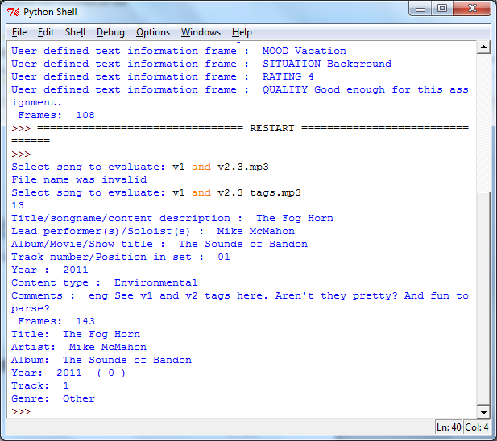

*This is an example of a file that has both version 1 and version 2.3 tags, as you can see, it outputs both versions.*

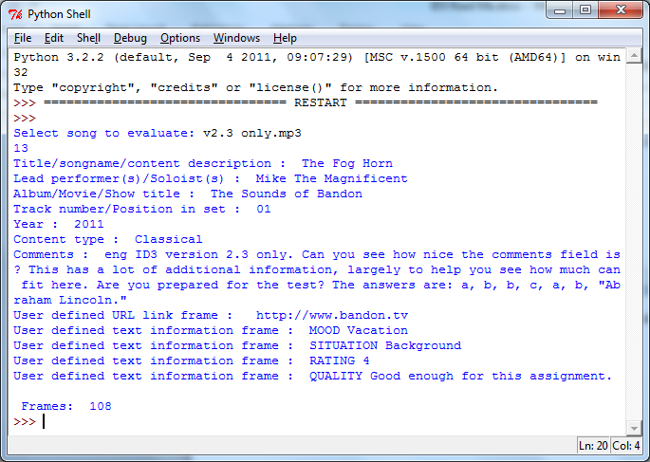

*This is an example of only the version 2.3 tags.*